DAY 4 ASSIGNMENT
1. Write a program to read and print elements of an array.
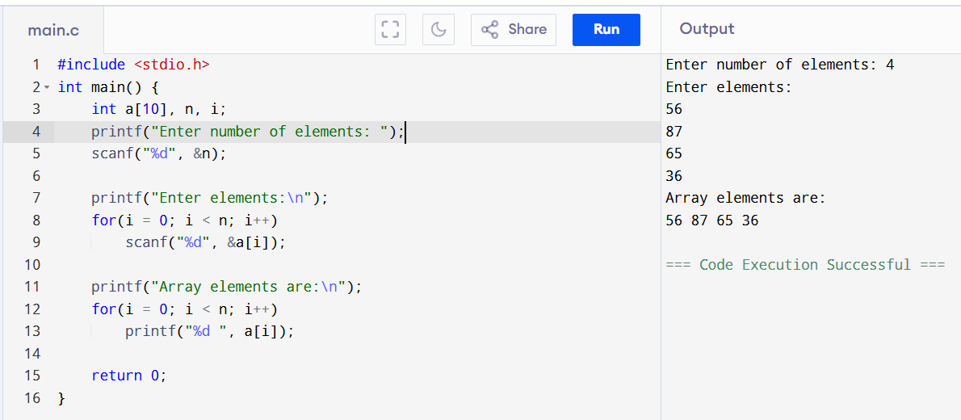
2. Write a program to find the sum of elements of an array.
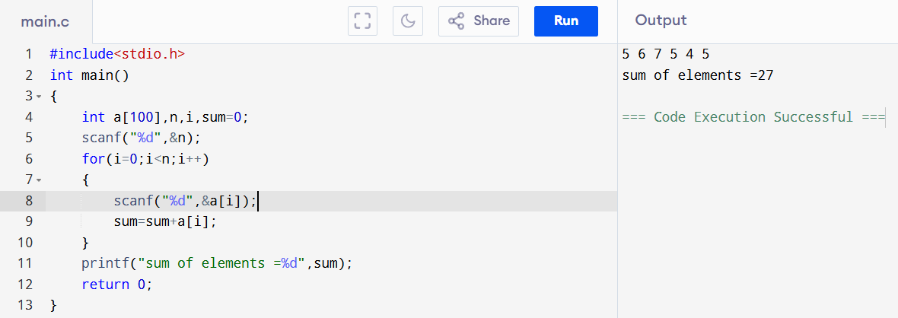
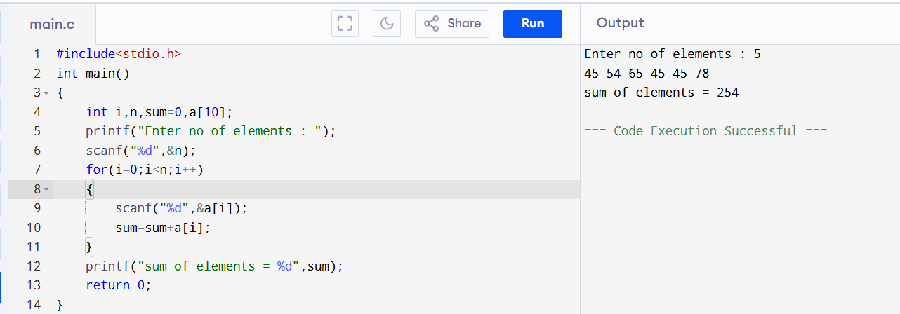

3. Write a program to find the maximum and minimum element in an array.
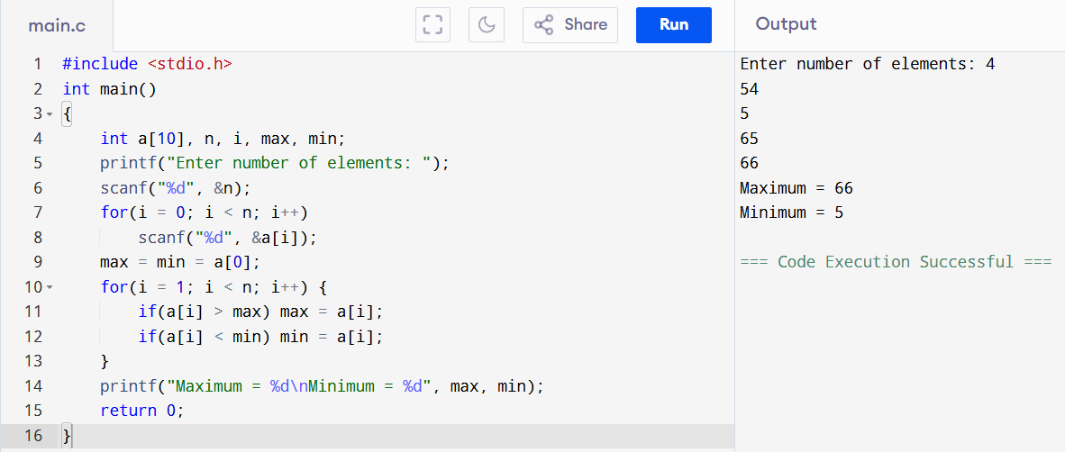

4. Write a program to reverse an array. 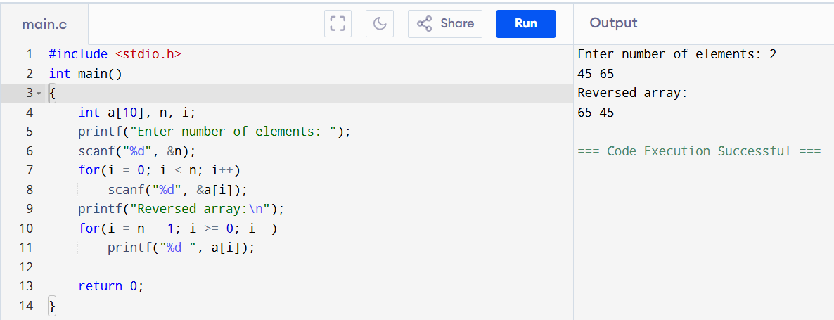
5. Write a program to search for an element in an array (linear search). 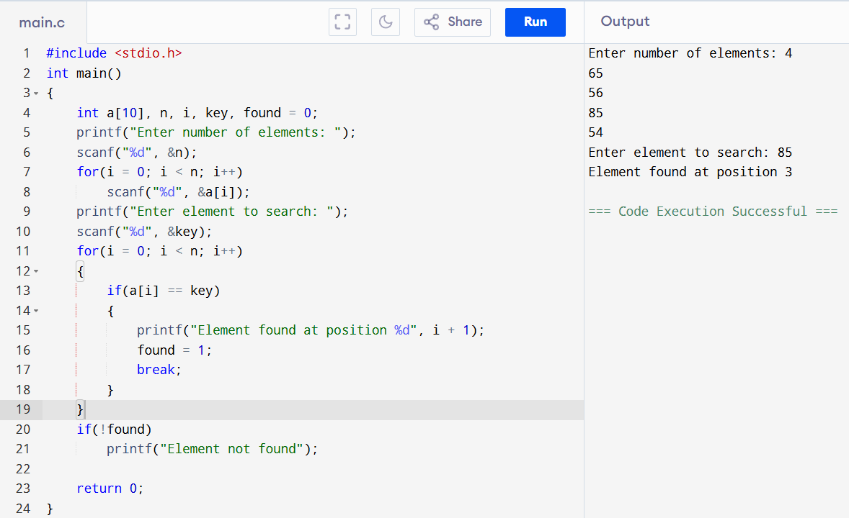
6. Write a program to sort an array in ascending order. 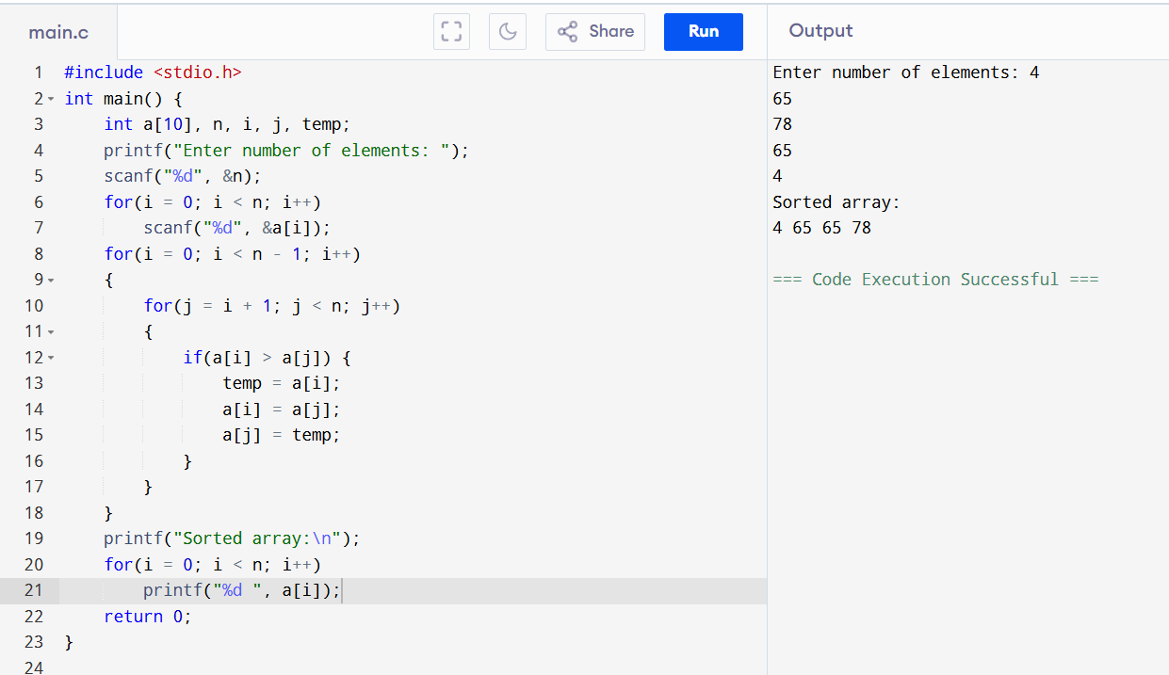

7. Write a program to insert an element in an array.
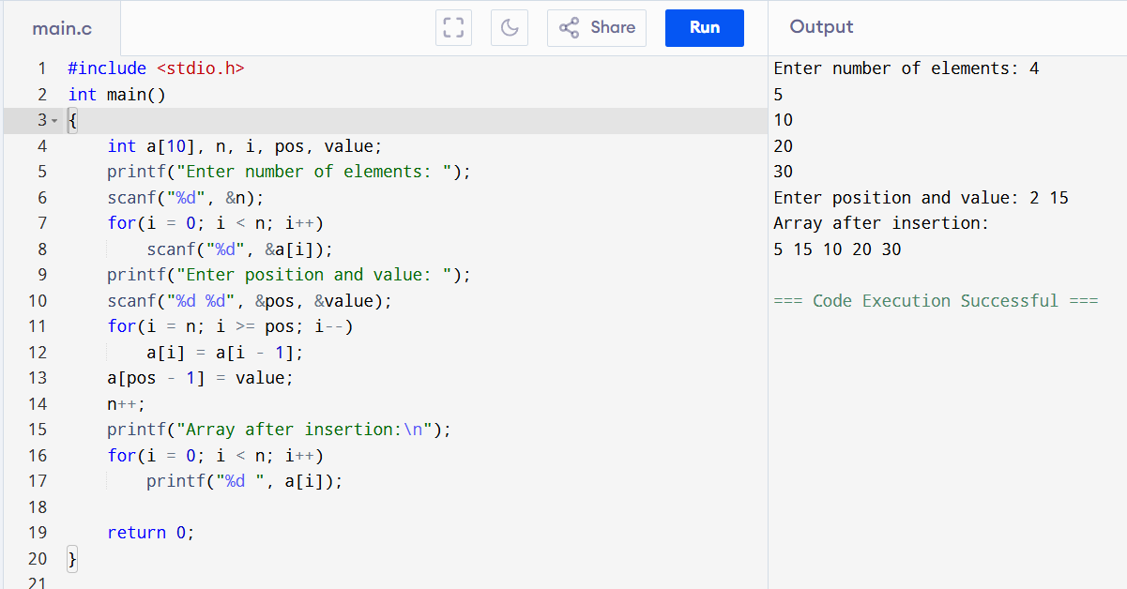
8. Write a program to delete an element from an array.
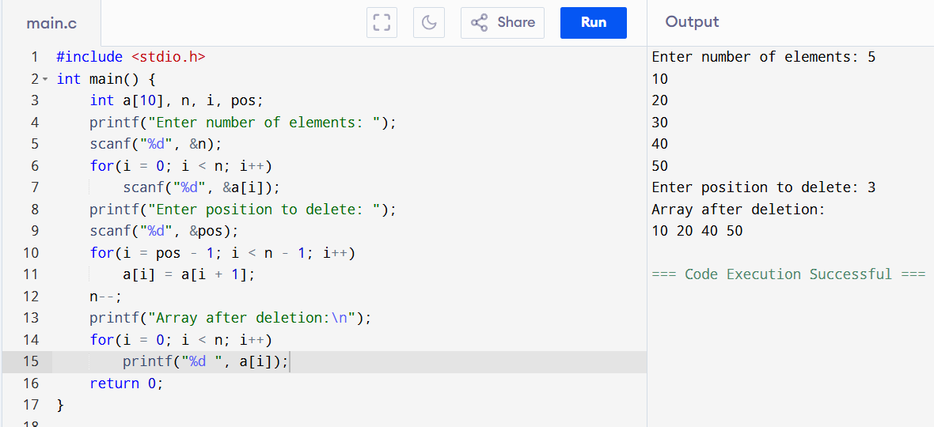
9. Write a program to find the frequency of elements in an array. 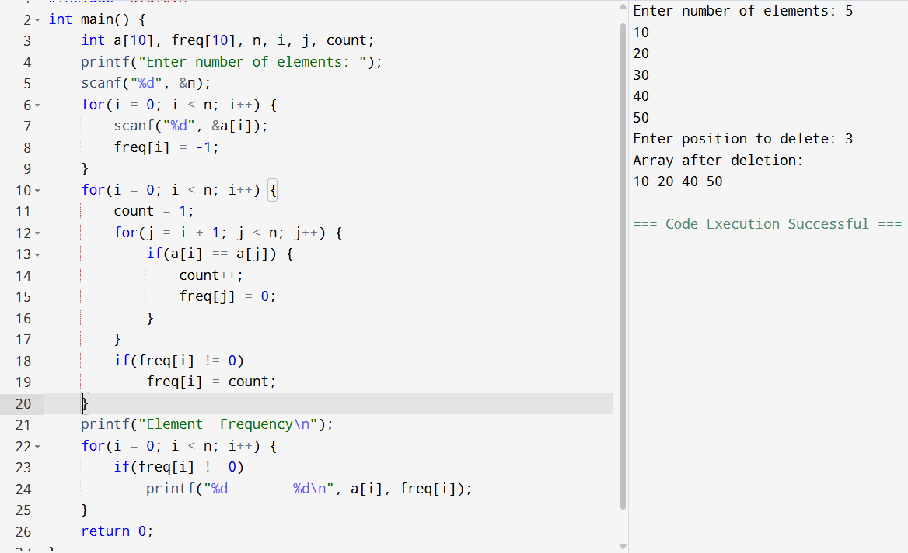
10. Write a program to merge two arrays.
